NANCY RUN FIRE COMPANY, INC.

Office of the Fire Chief
Joel Steirer, Fire Chief

3564 Easton Avenue
Bethlehem, Pennsylvania 18020-2944

Phone: 911 EMERGENCY
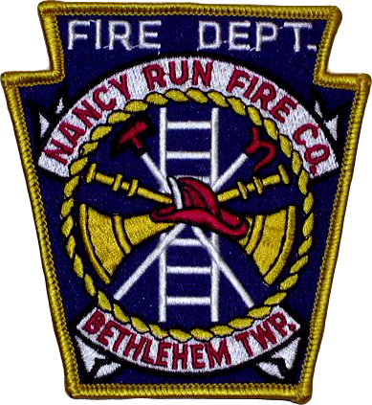
610-861-0234 Fire Station
484-239-2103 Cell Phone www.nancyrun.org

Apprentice Firefighter Permission Form

Joel Steirer, Fire Chief
Nancy Run Fire Company
3564 Easton Avenue
Bethlehem, PA 18020

Dear Chief Steirer,

This is to advise that I give consent and approval for _____________________ to serve in the capacity of Apprentice Firefighter with the Nancy Run Fire Company, Inc. of Bethlehem Township, PA.

I understand that during the period of his/her minority age, this consent and approval may be withdrawn by the minor’s parent or legal guardian at any time by written communication to the Fire Chief.

I understand that during the apprenticeship period, the above named minor shall automatically be a member of the Nancy Run Fire Company Relief Association and shall receive accident, medical and personal property damage coverage as provided by the Relief Association.

Thank you,

Parent/Legal Guardian:

Signature: ___________________________

Print Name: _________________________

Date: _______________________________

